Circle Language Spec: Classes

Target Classes
A target class is found by following the redirections, that lead to a symbol’s class.

< Move the good texts into the article with the diagrams, turning it into a single article. >

Do not follow more than one class redirection, because if a class points out a class again, then the second class is another class object, that the first class is just based on. If the class is an object reference itself, you have to follow all object redirections to find the target class object. Then you have found the target class. That’s where redirection following ends. If the class object has a class itself, you might be tempted to follow the class object’s class redirections as well, to find the final target class, but you should not do that. The first class redirection indicates the class. If that class object has a class itself, then the class object is only based on another class, but it is a class on its own. An object redirection is just a much tighter bond like that, than a class redirection.

Ideas

Out of the original Symbol documentation

Tracing Object Aspects
Formerly I’ve said that when you encountered a symbol that doesn’t have a type line, then it is the target type. But in Object Basics I said that when a symbol doesn’t have a type line, the object line functions as the type line. Therefore, if a symbol has no type line, the type can still be redirected by an object line.
Finding the aspects of a symbol, such as target object or target type, is called a trace.

Type Trace
You’ll use type and object lines to trace the type. Follow the type line if it exists, else follow the object line. When you run into a symbol with no type or object line, then that’s the type.

When there is no type line, the object determines the type.

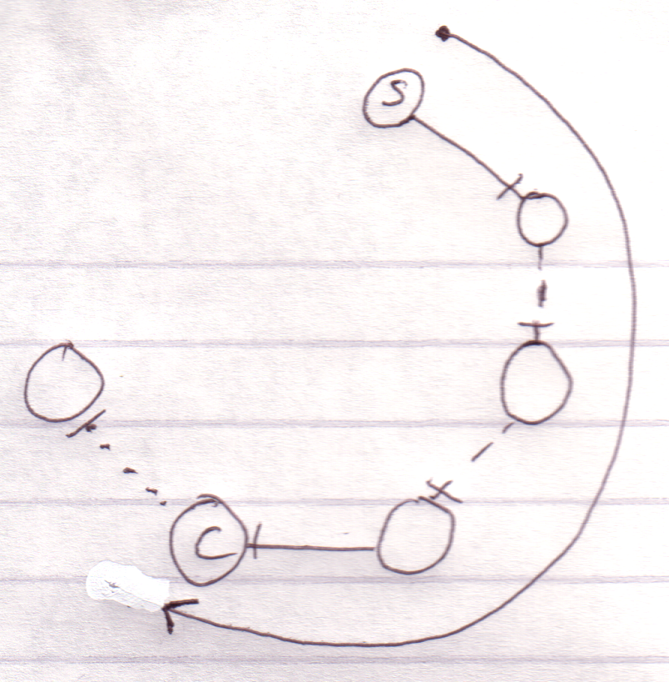

Interface lines are not followed. Note that the target type doesn’t have to be pointed to by a type line.

Object-Type Trace
The last symbol in the object trace altogether:

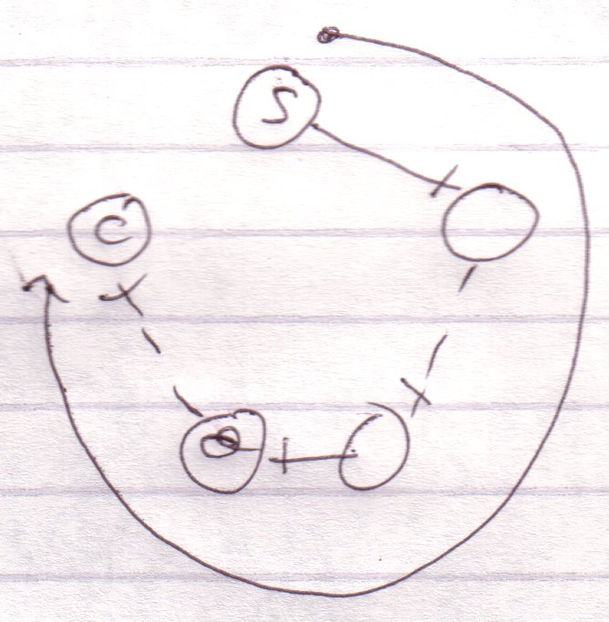

is the target type.

Therefore, object trace can also point out to the target type. The difference with a type trace is that a type trace prefers to follow type lines over object lines and an object trace prefers to follow object lines over type lines. However, both redirections lead to the exact same symbol.

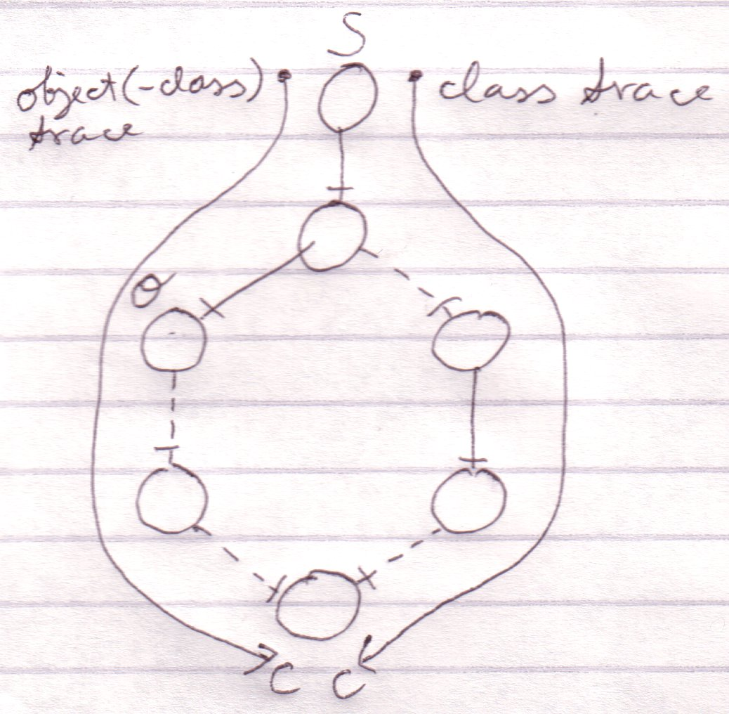

It happens a lot that you want to find out the object and the type in one blow. So you may as well use the redirection of the object trace for the benefit of finding the object and type in one blow. The trace is then called a object-type trace.

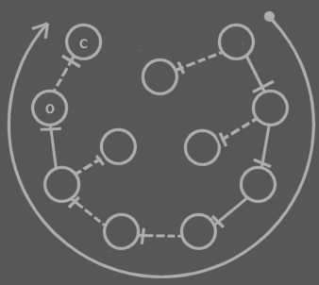

The last symbol in the redirection altogether is the target type (C). The last symbol pointed to by an object line is the object (O). Note that the target type may be pointed out by an object line.

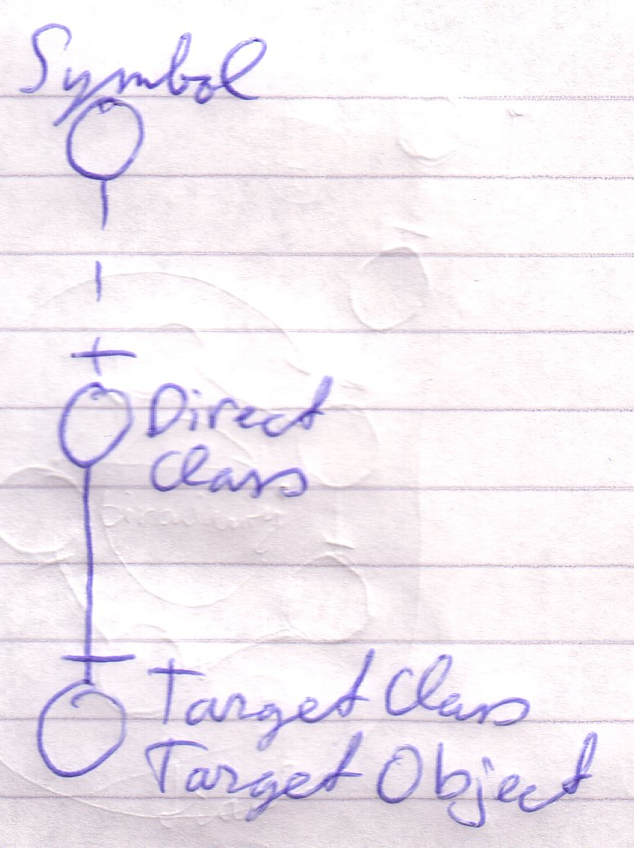

When you only want to find out the type, it is better to use a type trace than it is to use an object-type trace. Type trace prefers type lines over object lines. Type lines generally follow less redirections before reaching the target type than object lines do.

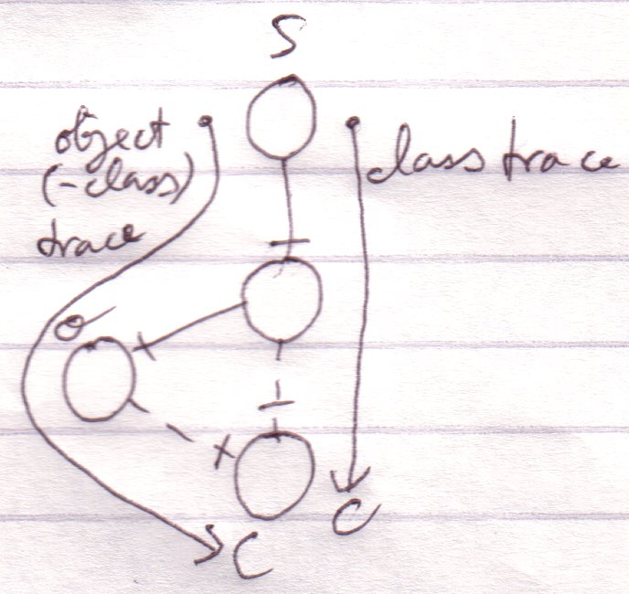

Tracing is Not Always Hard
If an object symbol has no object line or type line, then finding the target object and type is much simpler, because no redirectioning at all takes place. The symbol is its own object and type.



Traces usually don’t require as many steps as in the examples above.

Targets,
2010-05

> I do not know how it works yet. Now my mind says: follow all redirections, including multiple interface redirections… but in the Target Class story I stopped doing that. Maybe it is just what you want the term Target Interface to define. Maybe it is not even important. I don’t know.
> Perhaps there should be a distinction between interface definition and target interface. I do feel that both the ‘follow only one class or interface step’ version is a concept to be aware of, but the target interface concept would actually be following all redirections to find the object that actually determines the publics.
> Yes. What is now called Target Interface should probably be called the Interface Object and the Target Interface is the object after following all types of redirections in any order.

JJ

